Marcus Autism Center & Emory University Department of Pediatrics
5th Annual Summer Symposium on Autism Spectrum Disorders
Thursday-Friday, July 13-14th
2-DAY CLINICAL WORKSHOP
Autism Diagnostic Observation Schedule, Second Edition
Cheryl Klaiman, Ph.D.
8:30 – 9:00 Registration & Coffee

9:00 – 12:00 Overview of Mods 1-2 (Day 1) and Mods 3-4 (Day 2)

12:00 – 1:30 Lunch on Your Own

1:30 – 3:30 Administration and Scoring Practice

3:30 – 4:30 Discussion of Scoring and Coding Conventions

Wednesday, July 12th
A.M. Option 1: Translational Research

8:30 – 9:00 Registration & Coffee

9:00 – 9:45 Parent Training for Behavioral Problems in Children with ASD
Lindsey Burrell, Ph.D.

9:45 – 10:45 Early Vocal Development and its Derailment in ASD
Gordon Ramsay, Ph.D.

10:45 - 11:00 Break

11:00 – 12:00 Neuroimaging Studies of ASD: A Review of the Existing Literature & New Directions
Sarah Shultz, Ph.D.

12:00 – 1:00 Lunch on Your Own

A.M. Option 2: ETHICS WORKSHOP
David Jaquess, PhD, ABPP, BCBA-D

8:30 – 9:00 Registration & Coffee

9:00 – 10:15 Supervision Models and Ethical Frameworks

10:15 – 10:30 Break

10:30 -11:15 A Transactional Development Approach, Special Situations

11:15 – 12:15 Case Analyses, Break-Out Groups, Discussion and Course Evaluation

12:00 – 1:00 Lunch on Your Own

* This workshop will meet in the 3rd floor Board Room. It qualifies for 3 hours of CE credits for psychology in Georgia; full participation is required for credit.

Tuesday, July 11th
Intervention Programming

8:30 – 9:00 Registration & Coffee

9:00 – 10:00 Feeding Concerns and Obesity in ASD
Kristen Criado, Ph.D.

10:00 – 11:00 Advancing Educational Science: Classroom-Based Coaching to Foster Student Social Emotional Engagement
Lindee Morgan, PhD, CCC-SLP
Michael Siller, PhD

11:00 – 11:15 Break

11:15 – 12:15 Interventions to Promote Language in Minimally Verbal Children with ASD
Caitlin Delfs, Ph.D., BCBA-D

12:15 – 1:15 Lunch on Your Own

1:15 – 2:15 The Current State of Behavioral Interventions for Problem Behavior Exhibited by Individuals; Best Practices and Current Research
Nate Call, PhD, BCBA-D

2:15 – 3:15 Care Coordination and Patient Navigation
Cheryl Rhodes

3:15 – 3:30 Break

3:30 – 4:30 A Personal Perspective
Ryan Foley

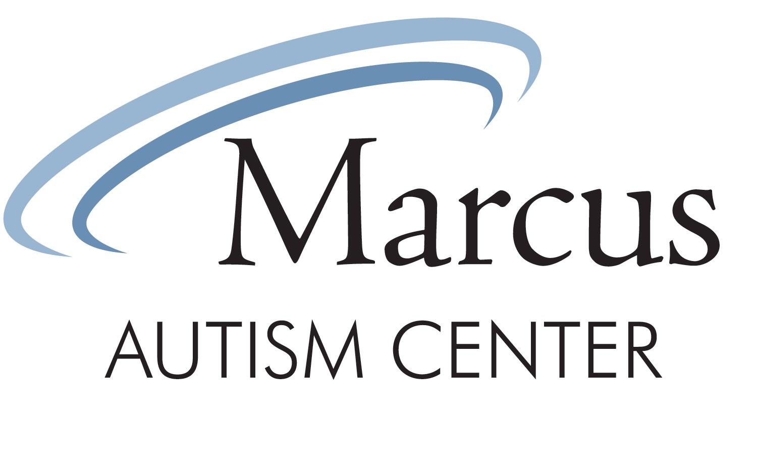
1920 Briarcliff Rd NE
Atlanta, GA 30329
Bellsouth Conference Room

Register on-line at http://www.marcus.org/About-Us/For-Professionals/Summer-Symposium
Monday – Friday
July 10-14, 2017

Single Day - $150 ($400 for M-W)
Half Day - $80.00
Students - $10/day ($25 for M-W)
ADOS 2-day Workshop - $500

*Approval for psychology CE credits are pending*
Wednesday, July 12th Afternoon

1:00 – 2:00 Studies of Social Visual
Engagement
Warren Jones, Ph.D.

2:00 – 2:45 Neurobehavioral Development in Infants at High-Risk for ASD
Jessica Bradshaw, Ph.D.

2:45 – 3:00 Break

3:00 – 3:45 Community-Based Early Intervention Models
Chris Watts, LMSW and Erica Chapman, Ed.D

3:45 – 4:30 Genetics in ASD: What Do We Know and What Does it Mean?
Chris Gunter, Ph.D.

4:30 – 4:45 Closing Remarks
Cheryl Klaiman, Ph.D.

Monday, July 10th
Defining, Detecting, & Diagnosing ASD

8:30 – 9:00 Registration & Coffee

9:00 – 9:15 Welcoming Remarks
Lynn Perez and Cheryl Klaiman, PhD

9:15 – 10:45 Overview of Autism Spectrum Disorder: Clinical & Research Perspectives
Ami Klin, Ph.D.

10:45 – 11:00 Break

11:00 – 12:15 Overview of Autism Spectrum Disorder: Clinical & Research Perspectives
Ami Klin, Ph.D.

12:15 – 1:15 Lunch on Your Own

1:15 – 2:15 Early Screening & Detection Methods
Cheryl Klaiman, Ph.D.

2:15 – 3:15 Early Social Communication Assessments
Moira Lewis, MS, CCC-SLP

3:15 – 3:30 Break

3:30 – 4:30 Dysmorphology
Karlene Coleman

