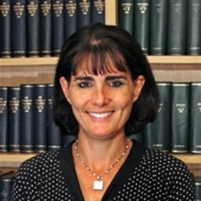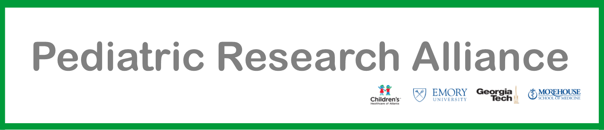

**“Harnessing Pediatric Brain Tumor Genomics to Impact Clinical Care”**

**Alyssa Reddy, MD**

Professor of Pediatrics

Director, Neuro-Oncology Program

UAB School of Medicine

**Sponsored by Children’s Center for Neurosciences Research**

**Friday, November 3, 2017**

**12:00 PM – 1:00 PM**

**Egleston Classroom 8**

**with Video Conferencing to Scottish Rite Sleep Lab and Chantilly Drive**

**Please** [**RSVP**](https://doodle.com/poll/6vth7e3x94wk9a5y) **for lunch by noon on Thursday, November 2nd**

**If you have questions or need additional information, please contact** [**Tracy Willoughby**](mailto:twillo2@emory.edu) **at twillo2@emory.edu**.