Courier Transfer of Samples from the Children’s Healthcare of Atlanta (CHOA) Center for Advanced Pediatrics (CAP) to the Emory University Children’s Clinical and Translational Discovery Core (CTDC)

Purpose

The purpose of this document is to outline the process by which clinical trial patient samples will be transferred from the Children’s Healthcare of Atlanta (CHOA) Center for Advanced Pediatrics (CAP), by Courier Connections, to the Emory University Children’s Clinical and Translational Discovery Core (CTDC).

Addresses

Children’s Healthcare of Atlanta (CHOA) Center for Advanced Pediatrics (CAP) 1400 Tullie Road NE, Room 5126, Atlanta, GA 30329

Emory University Children’s Clinical and Translational Discovery Core (CTDC) 1760 Haygood Drive, E-264, Atlanta, GA 30322

Contact Information

Nadine Spring
Director, Clinical Research Services
Emory University, Department of Pediatrics nadine.spring@emory.edu
404-727-5234
Mimi Le, PhD
Laboratory Director, Clinical and Translational Discovery Core
Emory University, Department of Pediatrics uyen.quynh.nguyen.le@emory.edu
404-727-2342

Process
- Upon arrival at the Children’s Healthcare of Atlanta (CHOA) Center for Advanced Pediatrics (CAP), see address above, a courier will be escorted to the Emory Processing Laboratory.
- After entering the laboratory (see Appendix I), the courier will retrieve samples from two locations:

  - An under-counter refrigerator (Appendix II and III)

  - An under-counter freezer (Appendix II and IV)

- Locate the sample log (Appendix V) that details the storage requirements of each sample.

- Verify that the items on the transfer form match the items that are placed in the pickup locations. Any discrepancies can be briefly detailed on the sample transfer form.
- Write the date and time of sample pickup as well as your initials on the sample transfer form.

- All samples will then be transferred in the same manner at which they were stored (refrigerated or frozen).
- Upon arrival at the Emory University Children’s Clinical and Translational Discovery Core (CTDC), the courier should place all samples in the appropriate storage location (Appendix VI).
- The courier should leave the sample log on top of the refrigerator/freezer (as pictured in Appendix VI).

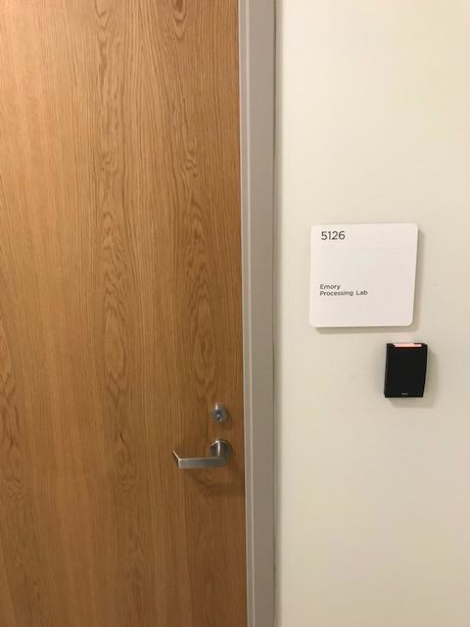

Appendix I. Children’s Healthcare of Atlanta (CHOA) Center for Advanced Pediatrics (CAP) Emory Processing Laboratory Main Door.

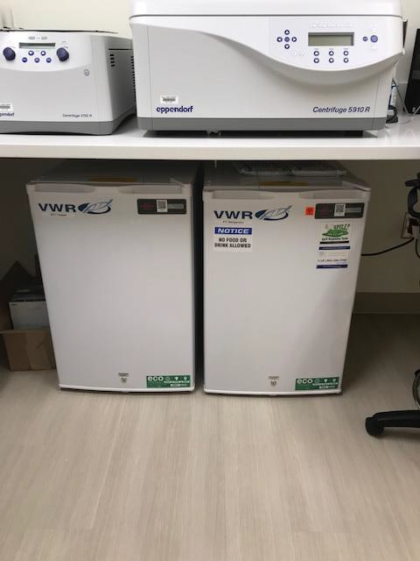

Appendix II. Sample storage location within the Children’s Healthcare of Atlanta (CHOA) Center for Advanced Pediatrics (CAP) Emory Processing Laboratory. Freezer/-20°C (left) and Refrigerator/4°C (right).

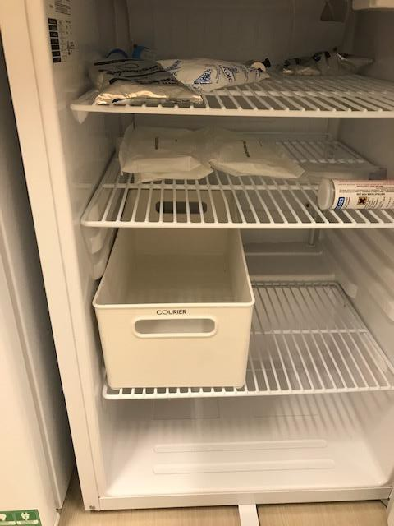

Appendix III. Children’s Healthcare of Atlanta (CHOA) Center for Advanced Pediatrics (CAP) Emory Processing Laboratory Refrigerator/4°C.

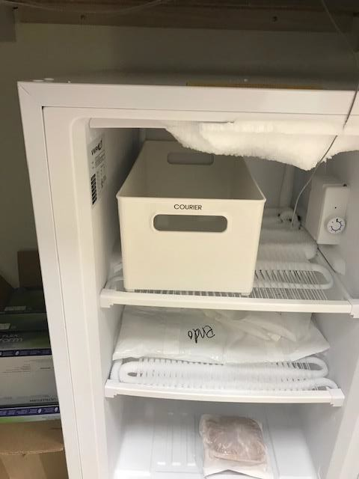

Appendix IV. Children’s Healthcare of Atlanta (CHOA) Center for Advanced Pediatrics (CAP) Emory Processing Laboratory Freezer/-20°C.

Appendix V

Sample Transport Log

Pickup Address:
Children’s Healthcare of Atlanta (CHOA) Center for Advanced Pediatrics (CAP)
1400 Tullie Road NE, Rm 5126, Atlanta, GA 30329
Drop-off Address:
Emory University Children’s Clinical and Translational Discovery Core (CTDC)
1760 Haygood Drive, E-264, Atlanta, GA 30322

Date | Time | Name | Sample Location (circle)
 |  |  | Refrigerator or Freezer
 |  |  | Refrigerator or Freezer
 |  |  | Refrigerator or Freezer
 |  |  | Refrigerator or Freezer
 |  |  | Refrigerator or Freezer
 |  |  | Refrigerator or Freezer
 |  |  | Refrigerator or Freezer
 |  |  | Refrigerator or Freezer
 |  |  | Refrigerator or Freezer

-------------------------------------To Be Filled Out By Courier Connection ONLY---------------------------------------
Sample Pickup
Date
Time
Courier Initials

Sample Drop-off
Date
Time
Courier Initials

Comments:

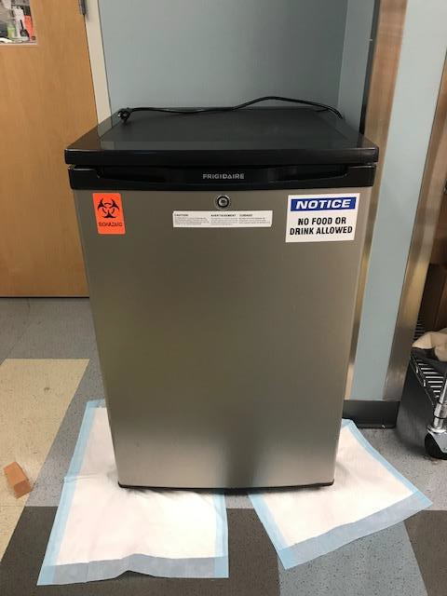

Appendix VI. Emory University Children’s Clinical and Translational Discovery Core (CTDC) refrigerator (bottom) and freezer (top).

