**Directions to the Georgia Aquarium for the**

**2023 Southeastern Pediatric Research Conference**

***Parking in the official Georgia Aquarium parking deck is included with your registration; please pick up a parking voucher at the registration desk when you arrive.***

**OCEAN BALLROOM ENTRANCE - 246 Ivan Allen Jr Blvd, Atlanta, GA 30313**

Please follow signs to the Oceans Ballroom on Level 1 of the parking deck. Once in the parking deck, USE THE WEST ELEVATORS on the corner of Ivan Allen Jr. Blvd and Luckie Street and follow signs to the Oceans Ballroom. PLEASE DO NOT FOLLOW SIGNS TO THE MAIN ENTRANCE/East Elevators. The East Elevators will take you to the main entrance of the aquarium, not the Ballroom.

**\*The main thing you need to know when arriving by MARTA is that you do not enter the conference area through the regular front entrance of the aquarium. The access to the conference center is by the parking deck off Ivan Allen, Jr. Blvd.**

MARTA by Train:  
The Georgia Aquarium is a 10-15 minute walk from the Dome/GWCC/Philips Arena/CNN Center Station on the Blue/Green line or from the Civic Center or Peachtree Center Stations on the Red/Gold line.

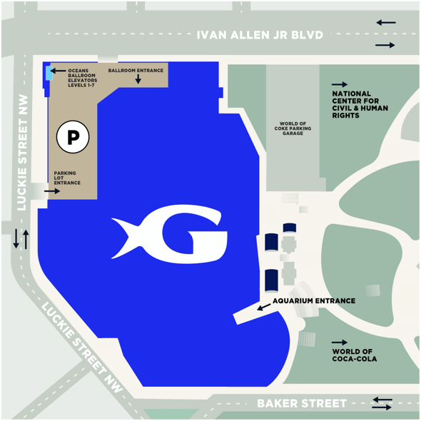MARTA by Bus:  
Bus service is available to the Georgia Aquarium from the Civic Center MARTA bus station and Five Points MARTA station via Route 32.