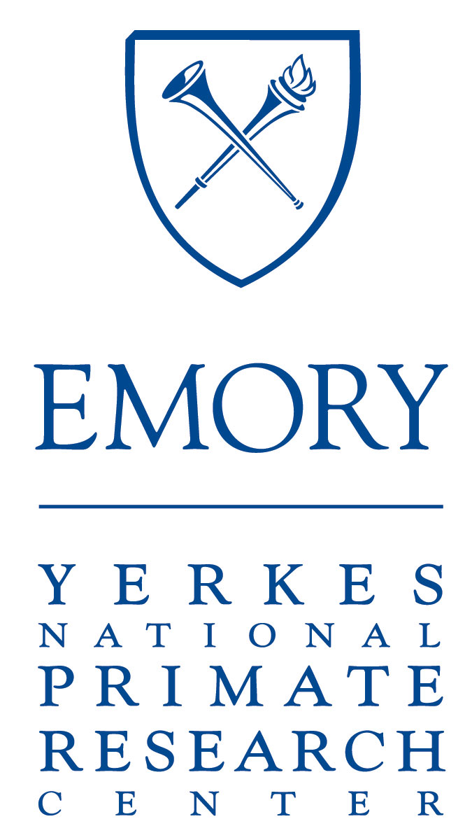 | Yerkes National Primate Research Center  Pilot Research Program 2017

The Yerkes National Primate Research Center is seeking proposals for new Pilot Research projects that will be funded from the upcoming year of the P51 base grant. We expect to make 2–3 awards.

These Pilot Research awards will provide one year of support for up to $70,000 in direct costs. Although the awards are open to all investigators, the NIH Office of Research Infrastructure (ORIP) guidelines require the direct involvement of a Yerkes Core Scientist, (see details below). We especially encourage applications from early career investigators and applications that propose translational research projects.

The projects will be judged on their potential to generate high-impact preliminary data that will result in peer-reviewed, research project grants from outside sources, and on how well they meet the five major review criteria per the ORIP NPRC and the NIH Office of Extramural Research guidelines, specifically—Significance, Approach, Innovation, Investigator and Environment.

Pilot Project proposals should conform to the following guidelines from the NIH:

- Pilot research must include activities related to the use of NHPs for biomedical research or for studies enhancing the welfare or husbandry of NHPs.
- Pilot research should be developmental or high risk and should be used to generate preliminary data or results necessary to apply for support from sources of funding such as NIH R01 grants.
- All activities related to the use of nonhuman primates (NHPs) must be conducted on-site at Yerkes. Other activities can be performed at other sites, depending on the nature of the pilot project. As relevant, a subcontracting mechanism within the pilot project can be used to support a portion of the pilot project performed outside of the grantee institution.
- Pilot research funds may not be used to provide interim support for established projects or for investigations funded from other sources.
- Pilot projects can be performed either by Yerkes personnel or by qualified personnel who are not Yerkes Core Scientists. The lead investigator (PI) of a pilot project need not be a Yerkes Core Scientist. However, Yerkes personnel must be involved in some capacity in the pilot project.
- All pilot research projects must be planned, conducted, and carried out under the supervision of at least one Yerkes Core Scientist. A Yerkes Core Scientist must assume responsibility for overall management, coordination, and progress reports.
- Projects that involve the active participation of investigators external to Yerkes are strongly encouraged, as are projects involving investigators who have not previously used NHPs and early career investigators.

Research proposals should strictly adhere to the requirements below. All text should be in Arial 11 pt font, using 0.5” margins. Include a header with the PI’s name and a footer with page numbers in the bottom center. Proposals should use the following section headings, with space allocated to each section as needed:

- A face page that provides the project title, principal investigator and proposed direct costs (a template is attached to this announcement).
- A brief research plan of no more than 3 pages total that includes:
  - A brief summary of the proposed project and specific aims
  - Significance
  - Innovation
  - Approach
  - Note: the research plan should specifically address how this project meets the NPRC criteria for Pilot Research projects and how the project will lead to future funding (or other outcomes)
- Literature cited (no more than 1 page); this section is not included in the 3 page limit for the research plan.
- NIH format Biosketch for the Principal Investigator only
- Budget (personnel, animals, assays, services, etc.) Please use the PHS 398 page 4 form (“Detailed Budget for Initial Project Period”) and include only direct costs.
- Budget justification (≤1 page), including brief descriptions of investigators and their roles.
- Other support for the PI and Core Scientist; potential overlap of the proposed project with existing funding should be explicitly addressed.
- Please do not include descriptions of available facilities or equipment unless important to the evaluation of the merit of the proposal.

Please be mindful of all the stated requirements—proposals that do not meet all of the requirements noted above will not be reviewed. When developing the proposed research plan, applicants proposing to use NHPs should be cognizant of the time required to obtain IACUC protocol approval as well as the time required for animal identification, quarantine, and final assignment. These potential time constraints should be incorporated into the duration of the proposed study. If you have questions about the feasibility of proposed NHP experiments or the availability of animal resources, please contact the Yerkes Associate Director for Animal Resources, Dr. Joyce Cohen (jkcohe2@emory.edu).

An investigator is allowed to apply for one proposal per funding cycle and can receive no more than one pilot project award every 2 years. Awards are for a single year. No-cost extensions with carryover funding are not possible due to the funding process of the P51 parent award.

Timeline:
- Proposal submitted as a single pdf to Denise Wardlow, assistant to Dr. Johnson, via e-mail (dwardlo@emory.edu) by 5 pm, Friday, March 31, 2017. Late applications will not be accepted!
- Projects will reviewed by the Yerkes National Scientific Advisory Board and funds awarded with an effective start date of May 1, 2017.

Yerkes National Primate Research Center
PILOT RESEARCH PROGRAM

Project Title
Principal Investigator

Name |  | Title
Telephone |  | Date
Division |  | Email
Budget

Period of Proposed Project | Start Date |  | End Date
Direct Cost of Proposed Project | $

